Api cho role manager:
+/token?role=manager:
-api để lấy token(hay login),query role để thông báo cho backend biết cần xác thực vớI role nào,manager là bảng của user admin và staff,student là bảng của user student,..
-method POST
-{
userName : String,
Password : String,
grant_type : “password”
}
-kiểu x-www-urlencoded

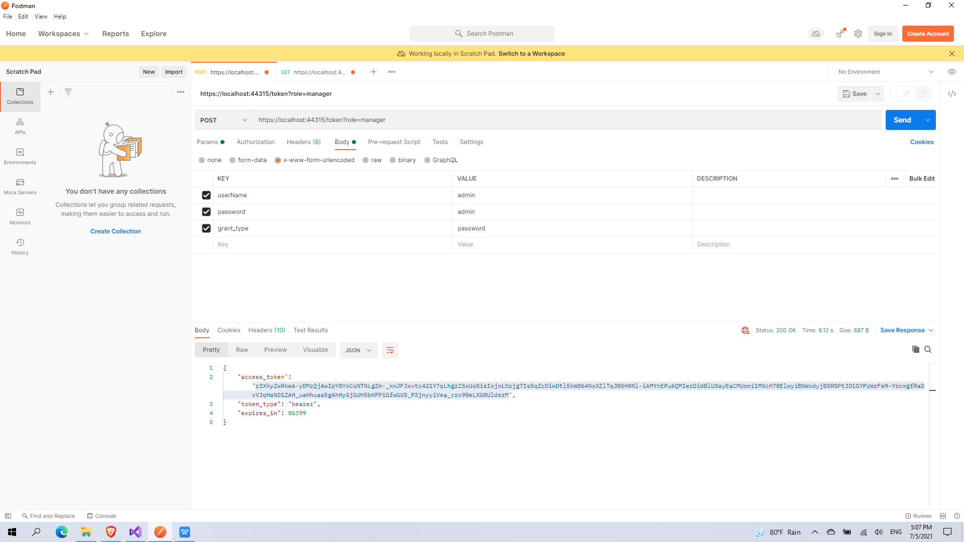

+/admin/{id}:
-api trả về thông tin 1 user manager có role là admin
-method GET
-Authorization header có dạng “Bearer //token”

